Java Script

its very popular language in front end development

now inspite of there quality I going to the main topics and concepts

data types

const let var

const it is fixed datatype just like final in java but only works in primitive types

let its not fixed data type

var its also not fixed

# Array is not premitive data type

there are two ways of declaring in JS (there are more but I know 2 ways which are comfortable)

1 by function => const name = new Array(value , value , value .. ………);
2 by traditionally → const name = [value , value];

calling all array value is only call there variable only

CURD in Array

in

ADDing
# name.push(value);
Update or rename
# name[arrayPosition] = [value]; (traditionaly);
#name.unshift();

Delete

pop functon for deleting

name.pop();
It has no parameters and it deletes by there peek point
shift() function also

name.shift()

# Finding the index :-?

name.indexOf(value);

# For Checking its present or not in array By boolean

name.includes(value); // its present or not if present than true , if not then false

ARRAYS vs Objects

39
12
I want to keep a list of strings that I will only ever check for the presence of, eg:
corporatePlan = [
'canDeAuthorize',
'hasGmailSupport',
'canShareReports',
'canSummonKraken',
'etc'
]
So, when the user tries to summon the kraken, I'll corporatePlan.indexof('canSummonKraken') != -1 to see ido f he can.
A coworker suggests that it would be faster to store it as an object:
"Corporate Plan" = {
'canDeAuthorize' : null,
'hasGmailSupport' : null,
'canShareReports' : null,
'canSummonKraken' : null,
'etc' : null
}

the imp thing is that in array you only call or use the values by there index and thats why there index order matter

but in objects every value has there own signature so the order does not matter and there index

in arrays and objects ways of calling

by dot notation which is generally used and
by bracket notation

plan.canSummonCracken
plan[“canSummonCracken”]

but in square brackets you can put any situation or expression

# prompt it gives a popup and placeholeder to input the values and after input the value your values is saved in prompt function variable

it is imp thing
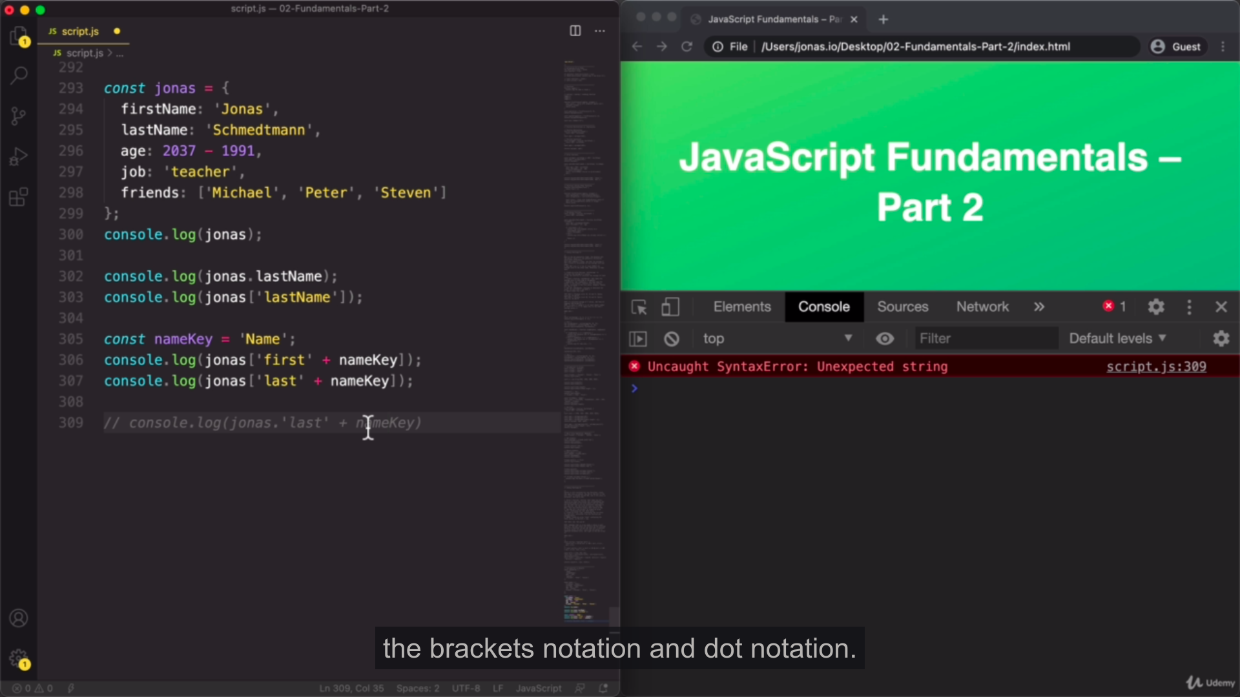
in array notation you call many values while in dot you call only one

in array notation you call use all operation above which we use in dot notation diffeence is we also used in multiple values;

#Array destructuring and Object Destructuring

Basically destructuring means to create new structure which is reduce and which we want at current situtatin

like in array destructing

let [] = arrayVariable / objectVAriable also

and in object destructing

let {} = objectVariable

main difference of dot notation and bracket nottation is you can add more values with the help of bracket notation but with the dot notation its not do
for see the code see fundamental.js script

when you define / assign array type expression in left side they called as destructuring variables

const [one , two ] = obj ;

the left side define expression is destructing variables

when you revision some parts of java script I give you the folder and file names for every

for dom implimentation JS => see 07 pig game , 05 guess my number , 06

and see the pdf for remember the strucutre

another for remember some fundamental concepts => ES6 fundamentals folder

// use rest operator when you want to pack multiple arrays , variables in one container

remember spread operator are present = right side and rest operator are present left side =

const [a , b , ...example] = [1 ,2 , 4 5,546,54,6 ,654,6,23] /// example of rest
console.log (...example) or (example) = > [packet

const arr = [1 , 23 ,4 5, 6,6,76,8,3]
console.log(...arr) // show only elements

// use spread when you want to add only array elements or use that elements only

